Computer Language Coding Concepts

Procedure in a Diagram
The term procedure is already defined in the article Procedure. The current article only shows the concept in a diagram.

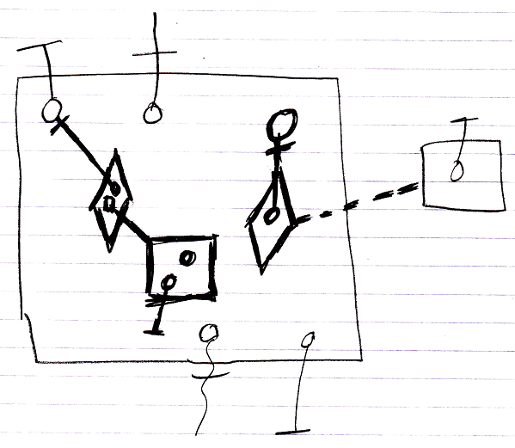

The contents of the large square, drawn with thick lines, are the command’s procedure, because they are all private contents The objects contained inside the large square, that are drawn with normal lines, are the command’s parameters.

See also: Procedure, Commands

Author & Copyright: Jan-Joost van Zon Date: August 25, 2008 – August 25, 2008 Location: Oosterhout, The Netherlands Status: Finished

